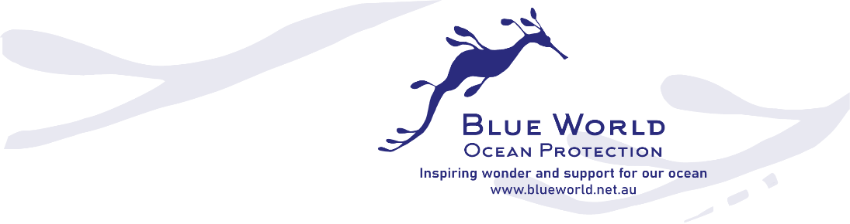

2024 Valerie Taylor Ocean Prizes
Inspiring wonder and support for our ocean
Blue World invites you to enter the 2024 Valerie Taylor Ocean Prizes. With a prize pool totalling $30,000, we aim to support a range of initiatives across NSW that focus on ocean protection and marine conservation engagement.
Valerie Taylor, a renowned diver, photographer, and trailblazing conservationist, has dedicated her life to protecting and inspiring support for our ocean and marine life. These annual prizes have been established to honour her achievements and ignite action for ocean protection and restoration.

Australians share a strong connection with the ocean. However, the marine and coastal environments are increasingly pressured by factors including climate change, marine pollution, species loss, coastal development and increased human activity.
We welcome your ideas to conserve our ocean, instil wonder and engage our communities in ocean stewardship, throughout the UN Decade of Ocean Science for Sustainable Development.
Aims and Criteria

The aims of the Valerie Taylor Ocean Prizes

- To make a direct impact on ocean protection and restoration.
- To create wonder, inform and activate our communities to protect and care for our oceans and particularly NSW marine eco-systems.

The prizes will be assessed according to the following criteria:
- The focus and potential impact of the project, with reference to the above aims.
- The feasibility and cost effectiveness of the project.
- Innovation and creativity of the project.
- Entrants’ potential to manage and evaluate an effective project.
- Partnerships, community engagement, collaboration, interdisciplinary approaches.
Who can enter?

Organisations and unincorporated groups, and individuals living or working in NSW’s coastal or harbour regions. We especially encourage applications from First Nations people, young people, regional communities, and those affected by climate chaos across NSW. Each group must include an adult support person. Each group is responsible for its own insurance needs.

Key Dates

Open date: 24 April 2024
Closing date: Submissions must be received by 11.59 pm, 30 June 2024
Prize Announcement: The recipients will be announced during Science Week, August 2024
Project Completion: The project must be completed and acquitted by April 2025

Valerie Taylor Ocean Prizes- Open Categories

Creative Conservation/Science Communication: Up to $3000 to support artists, musicians, and creatives working in science communication and ocean conservation events.
On theme: Costumes and props for campaigns or conservation events; music engagement, employment of artists/ illustrators to create resources, street performance, innovative science communication, campaign resources, equipment purchase, murals.
Marine Science and community engagement: Up to $3000 for a project, or project equipment
Direct Action: Up to $3000 for direct-action campaigns or projects focused on local ocean issues.
Valerie Taylor Ocean Prize – City East Categories
For projects based in Waverley, Woollahra or Randwick LGAs

City East Marine Science and community engagement: Up to $5000 for a project, or project equipment/ resources
Creative Conservation/Science Communication: Up to $3000 to artists, musicians, and creatives working in science communication and ocean conservation events.
To enter

Complete the 2024 Valerie Taylor Ocean Prize entry form by 30 June 2024.
www.blueworld.net.au
