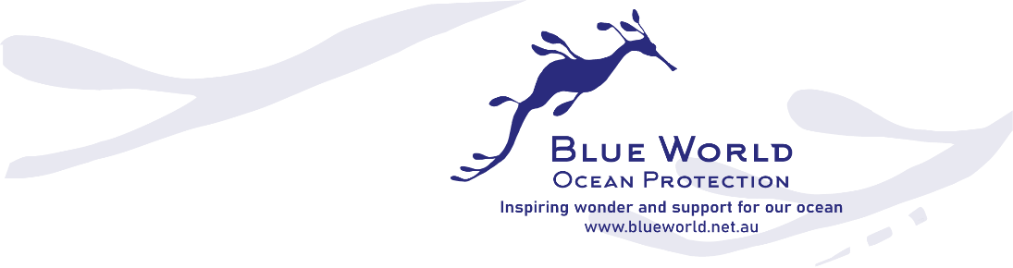

2023 Valerie Taylor Ocean Prizes
Inspiring wonder and support for our ocean
Calling all ocean change-makers! Blue World is pleased to announce the 2023 Valerie Taylor Ocean Prizes.
Valerie Taylor is a diver, photographer, and ground-breaking conservationist, who is dedicated to protecting and inspiring love for our ocean and marine life. These annual prizes have been established to honour her achievements and catalyse ocean protection.

Australians have a strong connection to the ocean. However, the marine and coastal environments we love are increasingly pressured by factors including climate change, marine pollution, species loss, coastal development and increasing use.
We welcome your ideas to conserve our ocean, create wonder and activate our communities. We invite you to help shape the future we want for our ocean, throughout the UN Decade of Ocean Science for Sustainable Development. We welcome creative ideas and encourage collaboration between conservationists of all persuasions. We need the arts, business, science, and community to mobilise to support ocean sustainability and make a positive impact for our ocean’s health.
Information and Guidelines

The aims of the Valerie Taylor Ocean Prizes

- To make a direct impact on ocean protection and restoration.
- To create wonder, inform and activate our communities to protect and care for our oceans and particularly NSW marine eco-systems.
The prizes can be used to focus on one or both, of these aims.
The prizes will be assessed according to the following criteria:
- The focus and potential impact of the project, with reference to the above aims.
- Clear outcomes and the feasibility of the project.
- Innovation and creativity of the project.
- Cost-effectiveness demonstrated in the budget.
- Entrants’ potential to manage and evaluate an effective project.
- Partnerships, community engagement, collaboration, interdisciplinary approaches and in-kind contributions are encouraged.

Who can enter?

Organisations and unincorporated groups, and individuals who either live or work in coastal or harbour regions in NSW. We especially encourage applications from First Nations people, young people, regional communities, and those affected by climate chaos across NSW. Each group must include an 18+ support person. Each group is responsible for its own insurance needs.
Key Dates

- Open date: 12 April 2023
- Closing date: All submissions must be received by 11.59 pm, 30 June 2023
- The prizes recipients will be announced during Science Week, August 2023.
- A significant part of the project must be completed and acquitted by 12 February 2024
Prize Recipient Responsibilities

- Comply with the aims, and contractual obligations of the prize
- Acknowledge Blue World support, display the Blue World logo on website and socials
- Complete budget acquittal
- Complete and share project evaluation with Blue World
- Provide digital images and/or video footage to Blue World for use on Blue World publications and social platforms
NSW Prizes

Blue World invites you to enter the Valerie Taylor Ocean Prizes. We are looking for impact and value with these prizes. We are likely to share the prize money between groups, so we can support more initiatives.
1 Valerie Taylor Ocean Prize for creative conservation /science communication
Up to $10,000 will be awarded across several projects
Supporting and engaging artists/ musicians/ creatives to add value to, science communication events and ocean conservation/ sustainability events or projects.
On theme: Costumes and props for campaigns or conservation events; music engagement, employment of artists/ illustrators to create resources, street performance, innovative science communication, campaign resources, equipment purchase, murals
2 Valerie Taylor Ocean Prize for marine equipment
Up to $5000
For equipment/ resources needed for marine science or ocean conservation/ocean literacy projects. Projects with clear ocean conservation aims will be prioritised.
On theme: marine science equipment, underwater camera hire, or purchase for a project.

3 Valerie Taylor Ocean Prize for direct action
Up to $3000
For a direct- action campaign or project that will focus attention on ocean issues.
On theme: Equipment, training and development, project resources
City East Prizes: Waverley/ Woollahra/Randwick

These projects must be based in Waverley, Woollahra or Randwick LGA.
It is open to Australian residents and groups with a significant connection to Waverley, Woollahra or Randwick LGA, including clubs, individuals and unincorporated groups. Each project is responsible for its own insurance, if required.

4 Valerie Taylor Ocean Prize – City East science
Up to $5000
For equipment or resources needed for marine science. Projects with clear ocean conservation/ restoration aims will be prioritised.
On theme: marine science equipment, underwater camera hire, or purchase for a project.
5 Valerie Taylor Ocean Prize for City East engagement
Up to $5000
A prize to engage new audiences in ocean conservation events, such as the Ocean Lovers Festival.
On theme: music engagement, artist employment, street performance, science communication.
6 Valerie Taylor Ocean Prize for a City East mural
Up to $2000
For a mural dealing with the themes of ocean conservation/ local marine ecology
Local artists will be prioritised. This prize may not be awarded as it depends on finding an appropriate wall. There are specific application questions for the mural.
Please download the Valerie Taylor Prize application form, to complete your submission.

